**Article** Title

Note: The title should be concise, informative and meaningful to the whole readership of the journal. It should include key terms to help make it readily discoverable when people search online. Please avoid using long systemic names and non-standard or obscure abbreviations, acronyms or symbols.

First name Last name (Name in other language) 1, First name Last name (Name in other language) 2 and First name Last name (Name in other language) 2

1 Department One, Institution One, City One, Country One, Address

2 Department Two, Institution Two, City Two, Country Two, Address

Note: Pease list all authors’ full names and institutions. Authors have the option to include names in Chinese, Japanese or Korean characters, in addition to the English name. The names will be displayed in parentheses after the English name. During the submission process, we recommend you supply [ORCID](https://publishingsupport.iopscience.iop.org/publishingsupport.iopscience.iop.org/orcid/) identifiers for all authors to avoid ambiguity. If an author’s current address is different from the address where the work was carried out, this should be explained in a footnote or the acknowledgement.

E-Mail: xxx

Received: xxx

Accepted for publication: xxx

Published: xxx

**Abstract**: Your abstract should give readers a brief summary of your article. It should concisely describe the content of your article and include key terms (especially in the first two sentences to increase search engine discoverability). It should be informative, accessible and not only indicate the general aim and scope of the article, but also state the methodology used, main results obtained and conclusions drawn. The abstract should be complete in itself; it should not contain undefined acronyms/abbreviations and no table numbers, figure numbers, references or equations should be referred to. Articles relying on clinical trials should quote the trial registration number at the end of the abstract. The abstract should be suitable for direct inclusion in abstracting services and should not normally contain more than 300 words. If you submit an article with an abstract longer than 300 words, we may rescind the manuscript and ask you to re-write it.

**Keywords:** Please supply up to 5 keywords for your manuscript. Suitable keywords would make it more discoverable. When choosing keywords, think about the kinds of terms you would use when searching online for related articles.

**Note:** **Video abstracts**We invite all authors to submit a video abstract along with their paper. This does not need to be sent in with the article when first submitted, but we must receive it within three weeks of acceptance to avoid delaying publication of the article. More information on video abstracts can be found on our [Publishing Support](https://publishingsupport.iopscience.iop.org/video-abstracts/) website.

1. Introduction

This should be concise and describe the nature of the problem under investigation and its background. It should also set your work in the context of previous research by citing relevant references. Introductions should expand on highly specialized terms and abbreviations used in the article to make it accessible for readers.

*Materials Futures* requires all references to be written using the Vancouver numerical system. References are numbered sequentially throughout the text. The numbers should be given in square brackets, e.g. [1], [4-7], etc., and one number can be used to refer to several instances of the same reference. The reference list at the end of the article then lists the references in numerical order. Ensure that all references are cited in the text and that all citations have a corresponding reference.

2. Methods

This section should provide sufficient details on the experiment, simulation, statistical test or analysis carried out to generate the results such that the method can be repeated by other researchers and the results reproduced.

**3. Results**

3.1. Subheading

|  |  |
| --- | --- |
| [add an equation here; use MS Word or MathType equation function] | (1) |

**Table 1.** Table Caption.

|  |  |  |
| --- | --- | --- |
| **Title 1** | **Title 2** | **Title 3** |
| entry 1 | data a | data b |
| entry 2 | data c | data |

a Table footnotes should be given as superscript letters as a, b, c, etc.

b The footnotes should appear at the foot of the table.

c The footnotes should consist of superscript lower case Roman letters starting with a, b, c, etc., with each new footnote starting on a separate line.

3.2. Subheading

Figure here

**Figure 1.** Figure Caption.

Note: Figures should be numbered in the order in which they are referred to in the text using sequential numerals (e.g. figure 1, figure 2, etc.). If there is more than one part to a figure (e.g. figure 1(a), figure 1(b), etc.), the parts should be identified by a lower-case letter in parentheses close to or within the area of the figure.

**4. Conclusion**

This section should be used to highlight the novelty and significance of the work, discuss the significance of the current results and compare them with previous work using relevant references.

**5. Future Perspectives**

Every manuscript is required to include a “Future Perspectives” section with around 600 words for review papers and 200 words for original research articles. This section should be used for forward-looking perspectives on material developments in relevant research areas, the author’s view on where this field is going, where the challenges and breakthroughs might be, etc. Authors are invited to be speculative based on the insights garnered from the main body of the manuscript.

Acknowledgments

All sources of financial support for the project **must** also be disclosed in the “Acknowledgements” section. The name of the funding agency and the grant number should be given, for example, in the form of: This work was partially funded by the National Institutes of Health (NIH) through a National Cancer Institute grant R21CA141833. When completing the online submission form, we also ask you to select funders and provide grant numbers to help meet funder requirements.

**Conflict of Interest**

During the submission process, all authors and co-authors are required to disclose any potential conflict(s) of interest when submitting an article (e.g. employment, consulting fees, research contracts, stock ownership, patent licenses, honoraria, advisory affiliations, etc).

**Author’s contributions**

We encourage authors to specify contributions and responsibilities for each author in the article acknowledgement section. Otherwise, all co-authors will be taken to share full responsibility for all of the paper. Authors may wish to use a taxonomy such as [CRediT](http://credit.niso.org/) to describe the contributions of each author.

#### References

Materials Futures requires all references to be written using the Vancouver numerical system. References are numbered sequentially throughout the text. The numbers should be given in square brackets, e.g. [1], [4-7], etc., and one number can be used to refer to several instances of the same reference. The reference list at the end of the article then lists the references in numerical order. Ensure that all references are cited in the text and that all citations have a corresponding reference.

Please note the following:

* Material that is a footnote to the text should not be included in the reference list.
* Copies of cited publications not yet available publicly should be submitted for the benefit of referees.
* Unpublished results and lectures should be cited for exceptional reasons only.
* Please reference and link to the original version of record (where it was first published) rather than to other versions of an article and/or a link to a repository or third party database.
* We discourage the referencing of online material hosted at web addresses that have no guarantee of perpetuity. Permanent or persistent web links should be used, as these are intended to remain unchanged for years into the future, yielding hyperlinks that are less susceptible to ‘link rot’. Examples of acceptable links include: [Digital Object Identifier (DOI)](https://www.doi.org/), [PubMed identifier (PMID)](https://www.ncbi.nlm.nih.gov/pubmed/), [PubMed Central reference number (PMCID)](https://www.ncbi.nlm.nih.gov/pubmed/), [SAO/NASA Astrophysics Data System (ADS) Bibliographic Code](http://adswww.harvard.edu/), and [arXiv](https://arxiv.org/) e-print numbers.
* Before submitting your article, please ensure you have conducted a literature search to check for any relevant references you may have missed.

#### Journal Articles

[1] Cantillano C, Mukherjee S, Morales-Inostroza L, Real B, Cáceres-Aravena G, Hermann-Avigliano C, Thomson R R and Vicencio R A. Observation of localized ground and excited orbitals in graphene photonic ribbons. 2018 New J. Phys. **20** 033028.

[2] The ASDEX Upgrade Team. Theory-based modelling of ASDEX Upgrade discharges with ECH modulation. 2002 Nucl. Fus. **42** L11.

**Books**

[1] Carter L N, Attallah M M and Reed R C 2012 Laser powder bed fabrication of nickel-base superalloys: influence of parameters; characterisation, quantification and mitigation of cracking Superalloys 2012 ed E S Huron, R C Reed, M C Hardy, M J Mills, R E Montero, P D Portella and J Telesman (Pittsburgh, PA: The Minerals, Metals, & Materials Society) pp 577–86.

[2] Whelan C T 2018 Atomic Structure (Bristol: IOP Publishing).

#### Conference proceedings

Note: SPIE Proceedings, AIP Conference Proceedings and IEEE Transactions should be treated as journals:

[1] Mahanta N K and Abramson A R 2012 Paper title 13th Intersociety Conf. on Thermal and Thermomechanical Phenomena in Electronic Systems

[2] Levin A D and Shmytkova E A 2015 Paper title. Proc. SPIE **9526** 95260P

[3] Smith M 2004 Paper title. AIP Conf Proc. **94** 340–9

[4] Stoffels E et al 2008 Paper title. IEEE Trans. Plasma Sci. **36** 1441–57

#### Conference series

[1] Holstein B R 2009 Title of the conferences J. Phys.: Conf. Ser. **173** 012019

#### Web links

Only permanent or persistent web links should be used in reference lists. Examples of acceptable links include:

* Digital Object Identifier (DOI)
* PubMed Identifier (PMID)
* PubMed Central ID (PMCID)
* SAO/NASA Astrophysics Data System (ADS) Bibliographic Code
* arXiv e-print number

#### Unpublished

[1] Jones R and Brown A 2011. Title. arXiv:0912.1470

[2] Dobson C T J 1968 Magnetic transport in reaction–diffusion phenomena PhD Thesis Brunel University, London

[3] Chandrasekhar J R 2003 Modelling aspects of model based dynamic qos management by the performability manager Lecture Notes Institute of Technology Delhi, India

#### Accepted or submitted or in preparation

[1] Jones R and Brown A 2011 Class. Quantum Grav. accepted

#### Non-bibliographic text

References that do not contain bibliographic information (i.e. they do not refer to other pieces of work) should be set as a footnote within the text and cited at the appropriate location.

**Other information**

**Reviewer Recommendation**

Authors are recommended to suggest three referees with detailed contact information, like email address, affiliation, etc. Authors can also list reviewers with potential conflict of interest during submission.

**Research Data**

This journal has adopted [IOP Publishing's standard data policy](https://publishingsupport.iopscience.iop.org/iop-publishing-standard-data-policy/). Please check that your article complies with the policy before submission.

Many research funders now require authors to make all data related to their research available in an online repository. Please refer to the [policy](https://publishingsupport.iopscience.iop.org/iop-publishing-standard-data-policy/) for further information about research data, data repositories and data citation.

**Graphical abstract**

A graphical abstract is an image that summarizes the main findings of a paper. It adds a rich, visual component to the start of a paper, helping readers to quickly appreciate and understand the central message. Graphical abstracts may be submitted at any stage. The image should be 590 x 690 pixels (height × width) with 300 dpi or higher, using Arial font with a size of 12–16 points; smaller fonts will not be legible online. Visual elements should balance clarity with substantive content, presenting complex information through accessible design. Authors are encouraged to incorporate color strategically to enhance data interpretation while maintaining academic rigor.

* The graphic should uphold the standards of a scholarly publication.
* The graphic should not include a photograph, drawing or caricature of any person, living or deceased.
* Do not include postage stamps or currency from any country or trademarked items (company logos, images and products).
* Avoid choosing a graphic that already appears within the text of the manuscript.
* **Examples of graphical abstracts**

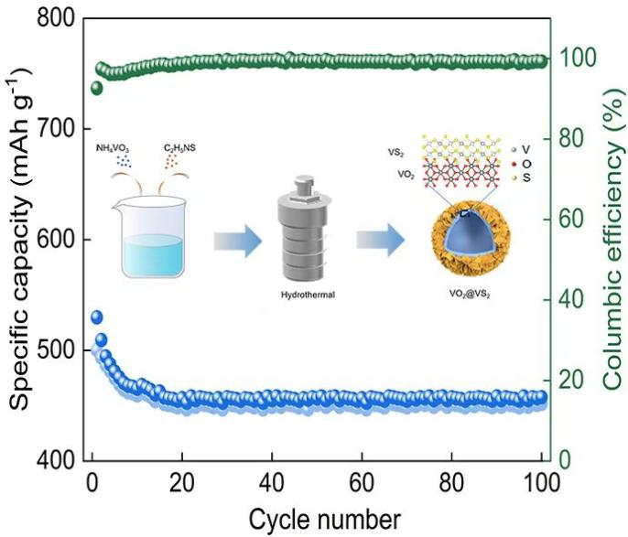

**(×) GA. 1 (Inappropriate)**

**NOTES：**

* It is recommended to use grading figures.
* Fonts should be in **Arial**.
* Images should be no larger than 590 x 690 pixels (height × width) with a minimum resolution of 300 dpi.
* Please refer to this website for color combinations and selections (https://www.design-seeds.com/) and pay attention to styles of arrows and other elements.

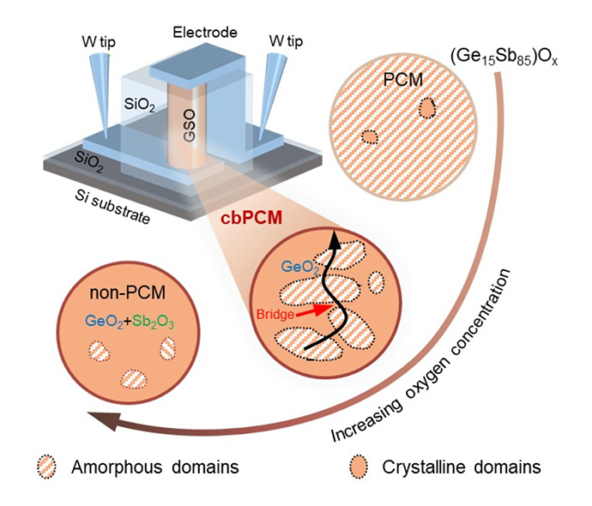

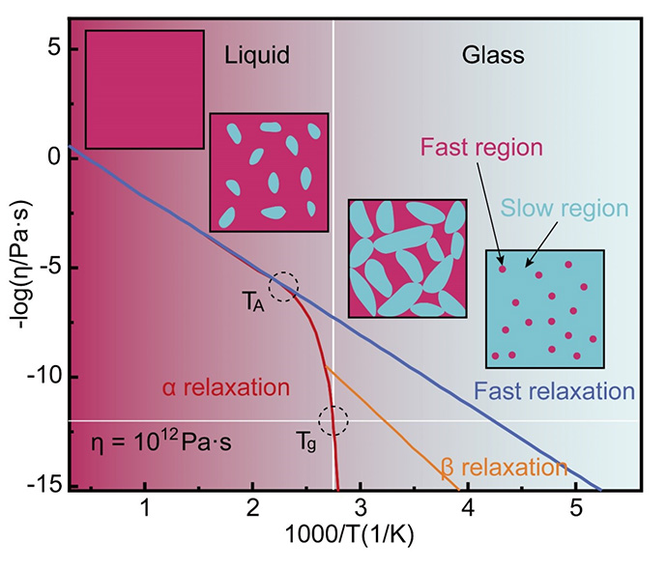

**(√) Recommended**

**Figures**

Carefully chosen and well-prepared figures, such as diagrams and photographs, can greatly enhance your article. You are encouraged to prepare figures that are clear, easy to read and of the best possible quality and resolution. Figures are converted and sized to the journal template as part of the production process for accepted articles, but they are not normally edited further. It is your responsibility to ensure that the figures you supply are legible and technically correct. Micrographs should include a scale bar of appropriate size, e.g. 1 μm.

Figures should be numbered in the order in which they are referred to in the text, using sequential numerals (e.g. figure 1, figure 2, etc.).

* **Figure** **Labels**
* Labelling of axes, keys and so on should be in 'sentence case' (first word capitalized only) with no full stop.
* Units must have a space between number and unit and follow the nomenclature common to your field, except for special cases, like 1h, etc.
* Spaces not commas should be used to separate thousands. Unusual units or abbreviations should be spelled out in full or defined in the legend.
* If there is more than one part to a figure (e.g. figure 1(a), figure 1(b), etc.), the parts should be identified by a lower-case letter in parentheses close to or within the area of the **Figure using a, b, c, NOT a), b) … NOT A, B, C… NOT A), B), C)… NOT (a), (b), (c)…** *etc*., **with Font of Arial** see the below examples.
* Subfigures are recommended to be aligned up and down, with each column maintaining the same length and each row maintaining the same width.
* **Font in Figures**
* Fonts should be restricted to Arial, with sizes of no less than 9 pt (recommended).
* **Figure Size**
* The width of single-column figures should be 85 mm, that of full-column figures 175 mm (recommended).
* **Figure Resolution**
* No less than 600 **dpi** (recommended).
* **Acceptable Types**

**Vector files with editable layers prefered.**

* Vector formats: PSD, EPS or EMF.
* Bitmap images: TIFF, JPEG or PNG.
* Images/drawings coded using TeX/LaTeX.
* Graphics application source files (Photoshop, Illustrator or CorelDraw).
* **Figure Submission**
* Images/figures should be embedded in MS Word for peer review.
* Save each figure in a separate file, name it with “Fig” and the corresponding numbering, e.g. Fig 1. Upload all figures as one compressed file.
* **Examples of Figures**
* Example Fig. 1

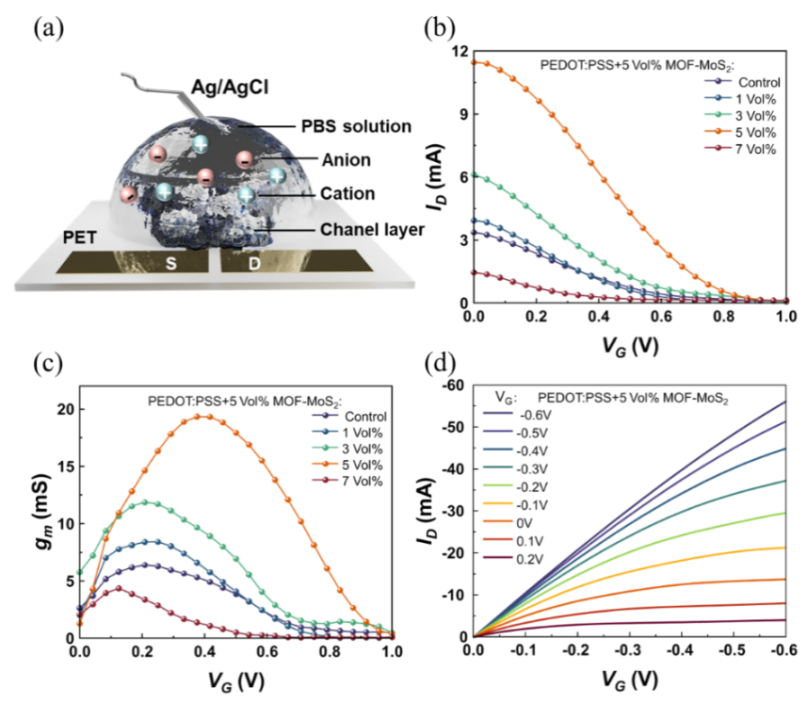

**(×) Fig. 1 Inappropriate**

* Font is not Arial; Space is missing before V

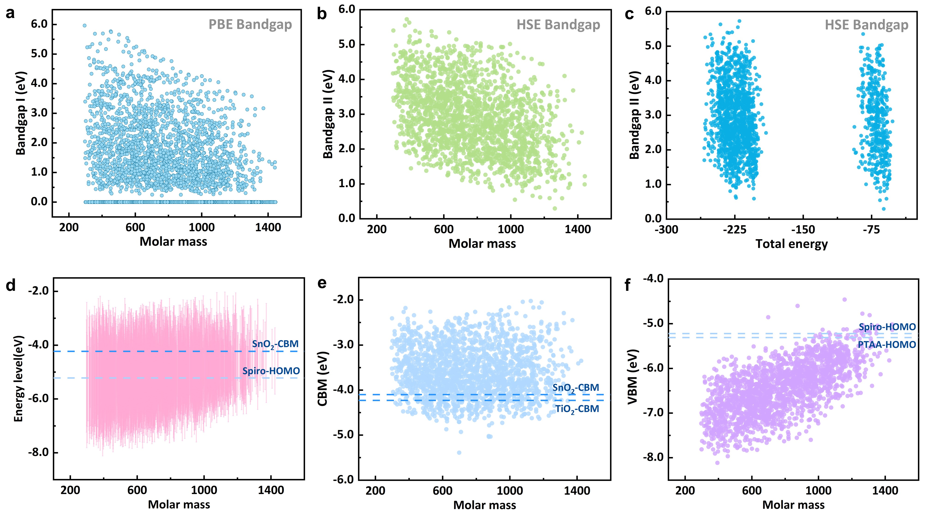

**(√) Fig. 2 Recommended**



**(√) Fig. 3 Recommended**

#### Inappropriate images

Please carefully consider both the subject matter and provenance of images included in your work before submitting to the journal. If the submitted images could be potentially offensive to the journal’s readership, IOP Publishing reserves the right to request that authors seek alternative images or other means to express the same results before the final version is published.

IOP Publishing will not consider submissions that feature the Lena/Lenna image, a crop of an image of Lena Söderberg from a 1972 issue of Playboy magazine, as its history conflicts with our commitment to [inclusivity in science](https://ioppublishing.org/open-physics/inclusivity/). Alternatives to the Lena image are widely available, see <https://www.tandfonline.com/doi/full/10.1080/09500340.2016.1270881> for examples.

#### Figure captions

Figure captions should contain relevant key terms and be self-contained (avoiding acronyms) so that readers can understand the figure without having to refer to the text. Figure captions should also reference the source of the figure if it has been reused from elsewhere.

#### Permissions

Note that it is the author’s responsibility to obtain written permission from the copyright holder for any figures you have reused from elsewhere. This will also include any figures that you created yourself, but have previously been published by another publisher, unless that publisher allows you to reuse them without permission under their author rights policy. Check individual publisher’s policies for details. Many scientific, technical and medical publishers use [RightsLink](http://www.copyright.com/get-permissions/) to grant permission. Information on how to request permission can usually be found on the website of each publisher. For further information about permissions and when permission is required, please see the [Permissions section](http://publishingsupport.iopscience.iop.org/permissions/).

Save each permission in a separate file, name it with **Fig X-ref [Y]** and also fill out the permission excel file. Upload all permission files as one compressed file.

#### Research Ethics

Authors should also note that the journal fully endorses the principles embodied in the [Declaration of Helsinki](https://www.wma.net/what-we-do/medical-ethics/declaration-of-helsinki/). All investigations involving humans must be conducted in accordance with these principles and in accordance with local statutory requirements. Some recommended clinical registration databases can be found at [clinicaltrials.gov](https://clinicaltrials.gov/), [the EU Clinical Trials Register](https://www.clinicaltrialsregister.eu) and [International Clinical Trials Registry Platform](http://www.who.int/ictrp/network/primary/en/index.html). Articles relying on clinical trials should quote the trial registration number at the end of the abstract.

All investigations involving animal experimentation must be conducted in conformity with the 'Guiding Principles for Research Involving Animals and Human Beings' as adopted by [The American Physiological Society](https://www.physiology.org).